Area Council Best Practices Score Sheet
Score 1‐5 with 5 fully meeting or exceeding the Practice, 4 almost meeting, 3 somewhat meeting, 2 doing only minimal and 1 not meeting.

Governance and Leadership
 | BEST PRACTICE | Score (1‐5)
1 | Area Council By-Laws or Standard Operating Procedures exist that identifies key positions, terms of office, succession language (e.g., Area Council Chair, Vice Chair, Executive Secretary, Treasurer, and other officers as needed) for the next 2+ years (present and incoming).
2 | At least 90% of Area Council organizations have identified an Area Council Liaison (Board Chair, Vice Chair or board member from the Executive Board) who is engaged in the work of the Area Council.
3 | National Area Council Committee Member participates in the planning meeting and the annual meeting by sharing information on the strategic direction of the Boys & Girls Club Movement and other key topics  impacting the Movement.
4 | The Director of Organizational Development, National Area Council Committee member, Chair and Executive Secretary conduct an Area Council review Area Council Performance using the approved Area Council assessment for Area Councils at least every two years.
5 | Policies are in place regarding finances; these policies are reviewed at least annually and shared with the membership. Annual reports of receipts and expenses are presented in detailed written form, discussed and  approved as necessary
6 | The Area Council sets a strategic direction for 2‐3 years and these long-range priorities become the Chart of Work for the Area Council membership and elected leadership. Where appropriate, alignment with State  Alliances will be critical. 90% of Area Council organizations vote in National matters.
Meetings and Conferences
 | BEST PRACTICE | Score (1‐5)
7 | The Area Council holds at least 4 meetings per year (one face to face), plus one or more of the following supported activities: Youth of the Year; All‐Staff Trainings, Cluster Trainings, etc.
8 | The annual meeting provides a minimum of 12 hours of learning (general and/or concurrent sessions), including Board Chair or Board Academy, training workshops and roundtables. Board leaders play an active role in planning, presenting, facilitating and engaging in dialogue at sessions during the Area Council meeting.
9 | Every organization’s board leadership has an opportunity for input in the planning meeting through attendance, conference calls or using survey tools.
10 | The Area Council offers a comprehensive learning experience for Board leaders with a focus on Board governance, resource development, financial management, human resource management, and the key priorities  of the Boys & Girls Club Movement’s Strategic Plan.
11 | Well planned business meeting with printed ballots as needed on all business, minutes from previous meeting and treasurers report. Minutes are stored per the documents retention policy. Only Board Members vote on action items.
12 | The leadership of the Area Council and State Alliance conduct joint planning meetings to ensure coordination on all meetings and activities within the state.
Participation
 | BEST PRACTICE | Score (1‐5)
13 | Organization has multiple board leaders actively engaged in Area Council with Chief Executive Officer. Board leaders take initiative and plan continuous learning opportunities for their board members and present  and interpret Area Council objectives and initiatives to local Boys & Girls Club organization.
14 | 100% of the organizations have Board leaders actively participate in the Area Council Annual Meeting. There is a formal agenda; minutes and meeting schedule are provided in advance. 100% participation (5 pts), 90 to 99% (4 pts), 80 to 89% (3 pts), 70 to 79% (2 pts), 60 to 69% (1 pt) <59% (0 pts)
15 | Formal networking/social activities are planned on the agenda for board members. Board members share best practices with other members of the Area Council.
Marketing and Communications
 | BEST PRACTICE | Score (1‐5)
16 | The Area Council Chair, Executive Secretary, and Director of Organizational Development communicate on a monthly basis. The Area Council leadership communicates to all members through emails,  newsletters, and phone calls on a quarterly basis. The Area Council’s communications contain essential, accurate information about Area Council activities that is updated regularly.
17 | The Area Council leadership communicates to the National Area Council Committee member on a quarterly basis and actively engages them in the planning and annual meetings.
18 | The Area Council is focused on recognition of its local members. The Area Council makes application for E.L. McKenzie, Clement Stone, Area Council Liaison, Board Member of the year, Jeremiah Milbank and years of service as appropriate. The council presents a minimum of 3 awards annually as part of its strategy which may include their own Hall of Fame recognition at its annual meeting.
TOTAL

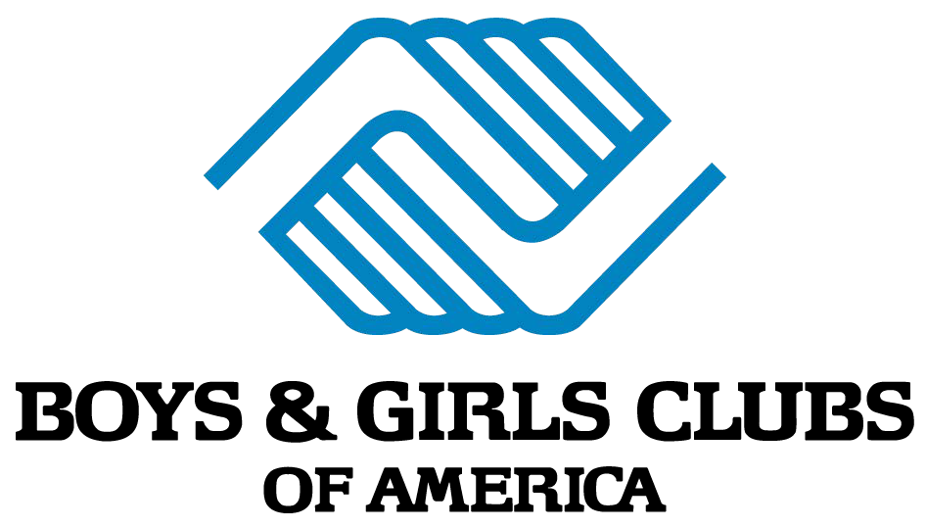
This scoresheet is intended for a quick and basic Area Council assessment. To complete a more detailed assessment, please ask your DOD or NACC representative for the Area Council Standards of Excellence document.

Draft #2 7/21/2018 1:30 PM CST
TOTAL SCORE
Gold Star ‐ Top of the Movement 81‐90 Silver Star ‐ Doing well but not there yet 63‐80 Participation Award ‐ But work to do 36‐63
Much work to do Below 36

